**Final Project: Disease Propagation Modeling**

**Group Members:** Nariman Al Kharusi, Naima Sagar, Revath Sankar, Michael Zeosky

**Submission Script:** Naima Sagar

Over the past two years, the COVID-19 pandemic has in some shape or form changed the life of every human being on the planet. As a result, scientists have spent thousands of hours and millions of dollars investigating the factors that affect the spread of the virus. Health professionals have been particularly concerned about how COVID-19 will continue to play out in developing countries, where social distancing is not always possible and medical infrastructure remains poor. Thus, for our project, we decided to investigate how the virus might spread in a remote village in India, a developing nation that has been severely impacted by the pandemic.

We began our analysis with a SIR base model, where the virus is allowed to spread through the village with no prevention measures implemented. The program begins with one infected person, who is then able to infect other people, and ends once no people are infected. We set the population of the village to be 10,000, the number of daily interactions between the villagers to be 10, and the recovery time of each person to be 5 days. After running through the model 10 times, we found that the disease propagated for around 17 days, peaking around the 9th day with around 9900 people infected (See Table 1).

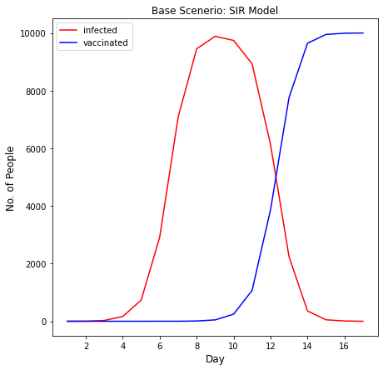

*Figure 1: Base Model with a population of 10,000 and daily interactions of 10.*

Considering the rapidity with which the virus spread through the population, the first prevention measure that we considered was mask wearing. To create the modification, we set the probability of a person wearing a mask to 50% and if the person was wearing a mask, reduced the likelihood of them being infected by 70%. We chose these numbers as in India, it is currently estimated that 50% of people wear masks and there is evidence to suggest that wearing a mask can reduce the likelihood of COVID-19 infection by 70%. After running through the model 10 times, we found that the length of disease propagation increased to around 24 days, peaking around the 12th day with 9300 people infected (See Table 2).

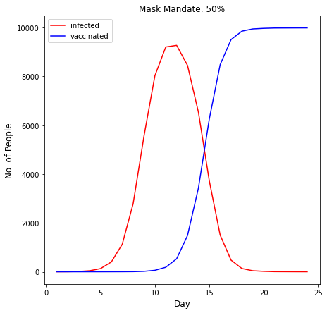

*Figure 2: Mask Model with a population of 10,000 and daily interactions of 10.*

Given that even with a mask mandate, the virus still spread through the population rapidly, the second prevention measure that we considered was the introduction of a vaccine. To create the modification, we implemented a random number generator which randomly vaccinated around 50% of the population. We chose this percentage as it was recently announced that over 50% of India’s eligible population have now been fully vaccinated. After running through the model 10 times, we found that the length of disease propagation increased even further to around 28 days, peaking around the 13th day with 4280 people infected (See Table 3).

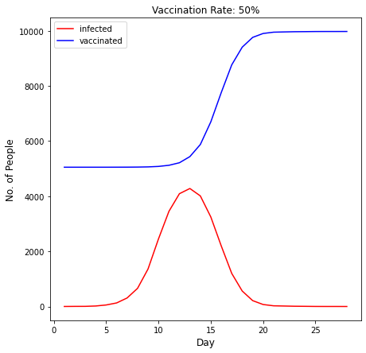

*Figure 3: Vaccine Model with a population of 10,000 and daily interactions of 10.*

Overall, our results indicated that both mask wearing and vaccinations were effective in slowing the spread of COVID-19. Both protection measures also resulted in fewer infections at and around the peak. This is notable especially when thinking about countries with a limited hospital capacity, like India, as it means that less people would need to be hospitalized at the same time. Furthermore, considering that both the mask wearing and vaccination rates in India currently stand at 50%, there is still scope for improvement in slowing the spread of the virus.

The next two modifications consider how COVID-19 would spread through a population under different cases. For our third modification, we decided to investigate the case of herd immunity. Scientists have estimated that herd immunity from COVID-19 will be achieved when roughly 80% of the population have been inoculated. At that point, a significant percentage of the population will be immune to the virus and its spread will be limited. To create the modification, we implemented a for loop that counts the number of inoculated people each day. Once the number of inoculated people was above 80% (or 8000), the probability of a person catching the virus reduced by 50%. After running through the model 10 times, we found that the disease propagated for around 25 days, peaking around the 13th day with 8610 people infected (See Table 4).

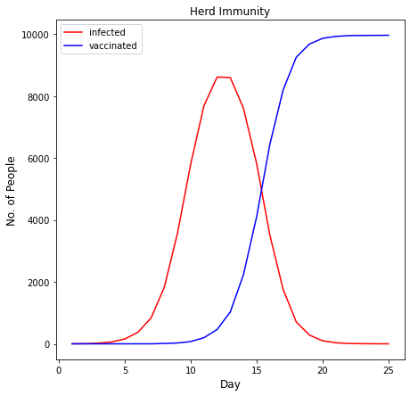

*Figure 4: Herd Immunity Model with a population of 10,000 and daily interactions of 10.*

In our final modification, we investigated how age might affect the spread of COVID-19. We also looked at whether varying the age of patient zero would change the propagation of the virus. To implement the modification, we created four age groups that had different recovery rates instead of the standard 5 days. This was done by introducing an “age” attribute in the “Person” class which assigns a random age between 0 - 100 to each person object that is created.

| **Age Group** | **Recovery Rate** |
| --- | --- |
| Age <= 16 | 3 days |
| 17 <= Age <= 25 | 4 days |
| 26 <= Age <= 60 | 5 days |
| Age >= 61 | 8 days |

*Recovery rates by age group.*

Our reasoning behind the differing age recovery rates stems from the evidence that older people are more vulnerable to becoming severely ill with COVID-19. Hence the oldest age group has the longest recovery rate. Moreover, COVID-19 cases have exhibited an age disparity which implies that some age groups are more susceptible to the virus than others. Therefore, in our “Population” object, we modified the boolean “luck” function to vary the probability of catching the virus by age.

| **Age Group** | **Susceptibility Rate** |
| --- | --- |
| Age <= 16 | 10% |
| 17 <= Age <= 25 | 15% |
| 26 <= Age <= 60 | 20% |
| Age >= 61 | 30% |

*Susceptibility Rate by Age group.*

To analyze the data, we considered two cases, one with a patient zero age of 75 and one with patient zero age of 25. After running through the data 10 times, we observed that in both cases, the point of intersection occurs on the 10th day on average. In addition, we noted that unlike in the base model, the number of infected and number of inoculated slopes are uneven past the points of intersection - this is due to different recovery and susceptibility rates. Overall, both data sets exhibit similar trends, implying that in spite of differing recovery times, patient zero’s age has little to no effect on the propagation rate of the virus (See Tables 5 & 6).

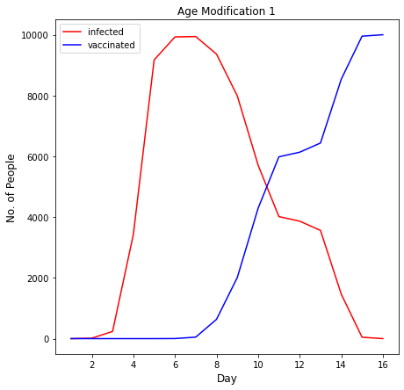

*Figure 5: Age Modification Model with a patient zero age of 75.*

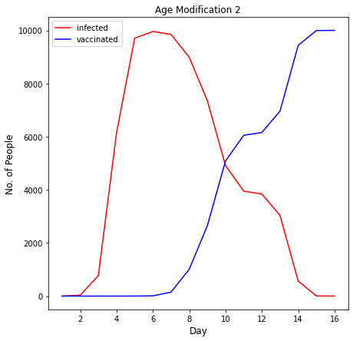

*Figure 6: Age Modification Model with a patient zero age of 25.*

In conclusion, the age modification exhibits some interesting trends. Whilst the disease propagates for roughly the same amount of time as in the base scenario, it should be noted that on average the peak occurs much earlier and is higher than in the base model. With a patient zero age of 75, the peak occurs on the 7th day with an average of 9941 infected and with a patient zero age of 25, the peak occurs on the 6th day with an average 9959 infected. In the base model, the peak occurs on the 9th day with an average of 9900 people infected. This finding is significant as it might change the way in which a nation prepares for a pandemic. In the age scenario, a government would need to assemble a larger amount of resources more quickly to effectively handle the number COVID-19 patients in its population. This is particularly helpful information to have in a nation with a large population and limited resources, like India. Overall, our modifications exhibited some interesting findings and there is certainly scope for further investigation.

Table 1: Base Model with a population of 10,000 and 10 daily interactions.

| **Days** | **Number Infected** | **Number Inoculated** |
| --- | --- | --- |
| 1 | 1 | 0 |
| 2 | 2 | 0 |
| 3 | 27 | 0 |
| 4 | 165 | 0 |
| 5 | 735 | 0 |
| 6 | 2915 | 1 |
| 7 | 7083 | 1 |
| 8 | 9451 | 9 |
| 9 | 9884 | 47 |
| 10 | 9741 | 245 |
| 11 | 8929 | 1070 |
| 12 | 6124 | 3875 |
| 13 | 2238 | 7761 |
| 14 | 357 | 9642 |
| 15 | 51 | 9948 |
| 16 | 9 | 9990 |
| 17 | 0 | 9999 |

Table 2: Mask Model with a population of 10,000 and 10 daily interactions.

| **Days** | **Number Infected** | **Number Inoculated** |
| --- | --- | --- |
| 1 | 1 | 0 |
| 2 | 3 | 0 |
| 3 | 12 | 0 |
| 4 | 42 | 0 |
| 5 | 128 | 0 |
| 6 | 403 | 1 |
| 7 | 1127 | 2 |
| 8 | 2786 | 5 |
| 9 | 5559 | 18 |
| 10 | 8028 | 60 |
| 11 | 9207 | 184 |
| 12 | 9274 | 532 |
| 13 | 8452 | 1487 |
| 14 | 6539 | 3427 |
| 15 | 3728 | 6256 |
| 16 | 1503 | 8483 |
| 17 | 478 | 9510 |
| 18 | 133 | 9856 |
| 19 | 42 | 9947 |
| 20 | 18 | 9971 |
| 21 | 5 | 9984 |
| 22 | 3 | 9986 |
| 23 | 1 | 9988 |
| 24 | 0 | 9989 |

Table 3: Vaccine Model with a population of 10,000 and 10 daily interactions.

| **Days** | **Number Infected** | **Number Inoculated** |
| --- | --- | --- |
| 1 | 1 | 5052 |
| 2 | 4 | 5052 |
| 3 | 5 | 5052 |
| 4 | 18 | 5052 |
| 5 | 55 | 5052 |
| 6 | 129 | 5053 |
| 7 | 309 | 5054 |
| 8 | 659 | 5057 |
| 9 | 1360 | 5064 |
| 10 | 2452 | 5081 |
| 11 | 3453 | 5122 |
| 12 | 4091 | 5214 |
| 13 | 4280 | 5437 |
| 14 | 4011 | 5876 |
| 15 | 3248 | 6697 |
| 16 | 2195 | 7762 |
| 17 | 1200 | 8765 |
| 18 | 562 | 9406 |
| 19 | 213 | 9761 |
| 20 | 72 | 9903 |
| 21 | 25 | 9950 |
| 22 | 17 | 9959 |
| 23 | 9 | 9967 |
| 24 | 6 | 9970 |
| 25 | 2 | 9974 |
| 26 | 1 | 9975 |
| 27 | 1 | 9975 |
| 28 | 0 | 9976 |

Table 4: Herd Immunity Model with a population of 10,000 and 10 daily interactions.

| **Days** | **Number Infected** | **Number Inoculated** |
| --- | --- | --- |
| 1 | 1 | 0 |
| 2 | 6 | 0 |
| 3 | 23 | 0 |
| 4 | 60 | 0 |
| 5 | 156 | 0 |
| 6 | 374 | 1 |
| 7 | 838 | 1 |
| 8 | 1832 | 11 |
| 9 | 3578 | 27 |
| 10 | 5804 | 73 |
| 11 | 7681 | 197 |
| 12 | 8610 | 461 |
| 13 | 8596 | 1029 |
| 14 | 7602 | 2234 |
| 15 | 5813 | 4108 |
| 16 | 3509 | 6435 |
| 17 | 1768 | 8186 |
| 18 | 708 | 9248 |
| 19 | 283 | 9675 |
| 20 | 98 | 9860 |
| 21 | 35 | 9923 |
| 22 | 11 | 9947 |
| 23 | 4 | 9954 |
| 24 | 2 | 9956 |
| 25 | 0 | 9958 |

Table 5: Age Modification Model with a population of 10,000, 10 daily interactions, and a patient zero age of 75.

| **Days** | **Number Infected** | **Number Inoculated** |
| --- | --- | --- |
| 1 | 1 | 0 |
| 2 | 13 | 0 |
| 3 | 237 | 0 |
| 4 | 3430 | 0 |
| 5 | 9173 | 0 |
| 6 | 9928 | 2 |
| 7 | 9941 | 49 |
| 8 | 9363 | 635 |
| 9 | 7987 | 2013 |
| 10 | 5710 | 4290 |
| 11 | 4016 | 5984 |
| 12 | 3865 | 6135 |
| 13 | 3562 | 6438 |
| 14 | 1462 | 8538 |
| 15 | 46 | 9954 |
| 16 | 0 | 10000 |

Table 6: Age Modification Model with a population of 10,000, 10 daily interactions, and a patient zero age of 25

| **Days** | **Number Infected** | **Number Inoculated** |
| --- | --- | --- |
| 1 | 1 | 0 |
| 2 | 34 | 0 |
| 3 | 769 | 0 |
| 4 | 6141 | 0 |
| 5 | 9705 | 1 |
| 6 | 9959 | 8 |
| 7 | 9848 | 148 |
| 8 | 8992 | 1008 |
| 9 | 7353 | 2647 |
| 10 | 4912 | 5088 |
| 11 | 3949 | 6051 |
| 12 | 3844 | 6156 |
| 13 | 3035 | 6965 |
| 14 | 564 | 9436 |
| 15 | 5 | 9995 |
| 16 | 0 | 10000 |